Partition of variation: an explanation and comparison of variance components analysis methods

Application of variance components analysis
Variance components are used to determine the variation due to single or multiple factors. In this paper the word factor will be used to describe a variable that is treated as an input (independent) whereas response is used to describe the dependent or output variable.
Primary applications for variance component analysis are:
- Identification of and prioritizing sources of variation to influence continuous process improvement projects aimed at eliminating or reducing these sources of variation.
- Determining amount of variation in analytical methods. This typically includes the intra-assay error and the inter-assay error. Fitness for use can be determined by evaluating the variance components in an instrument or analytical method.

History of variance components analysis
Multiple traditional variance components analysis methods have been developed. Recognized techniques are Expected Mean Square (1921), Restricted Expected Maximum Likelihood (REML) (1937) and Bayesian variance components estimation. Most of these techniques predate the invention of the computer and have not changed much with the advent of modern computers. Restricted maximum likelihood is currently the recommended standard in guidance from United States Pharmacopeia (USP <1033>), whereas NIST cites Expected Mean Squares. All these methods have limitations for what elements they calculate and how they are calculated.
Variance component method | Data symmetry | Between | Within | Common | Data type
EMS | Balanced | Yes | Total only | No | Categorical
REML | Unbalanced | Yes | Total only | No | Categorical
Bayesian | Unbalanced | Yes | Total only | No | Categorical
POV | Unbalanced | Yes | Full breakdown | Yes | Categorical and continuous

Partition of Variation (POV) was developed by Thomas A. Little in 1993 for the analysis of semiconductor data in disk drive manufacturing. In 2015 Thomas A. Little and Paul Deen collaborated on expanding the functionality of the POV to include measurement system analysis (MSA). The primary implementation of POV is publicly available as a JSL script for use in JMP statistical software. The script can be found on the website https://thomasalittleconsulting.com. A limited implementation is available as package for R statistical software. This was developed in 2020 by Paul Deen and is available for installation from CRAN and Github.

Technical Description of POV
The following the method of calculation used in the POV methodology.
Some factors may influence the mean of the response, other factors may influence the standard deviation of a response, some factors influence both the mean and standard deviation and unexplained variation is reported as common across all treatments. Partition of variation uses the term between to describe the change in the mean and within to describe the change in the standard deviation. Some variation is always present and may not be due to the factors under investigation. This minimum variation is called the common variance. Common variance is the minimum amount of variance present in all unique combinations of factor levels.
Figure 1 three types of variation
Typical study designs are crossed, nested and main effect. In a crossed study design all factor combinations are crossed with each other, figure 1. Crossed studies result in multiple factor interactions. In nested studies the factors are order dependent (parent child) and interactions are not possible. Main effects are used for two conditions; 1) when only 1 factor is in the study design and 2) when the data structure is unclear (partially nested or partially crossed).

Machine A
Machine B
Machine C
Metrology X
Metrology Y
Metrology Z
Figure 2 two factor crossed study design
From the example in figure 2 the complete list of variance components is:
$${SD}_{Overall}=\sqrt{\begin{aligned}{SD}_{Between Machine}^{2}+{SD}_{Between Metrology}^{2}+{SD}_{Between Machine*Metrology}^{2}+ {SD}_{Within Machine}^{2}+ \\ {SD}_{Within Metrology}^{2}+{SD}_{Within Machine*Metrology}^{2}+ {SD}_{Common}^{2} \end{aligned}}$$
To demonstrate how POV methodology works, an example dataset is analyzed. The data contains one response and the factors machine and metrology with three levels each:
Figure 3 Data overview
The response has a variance of 0.0466. Both machine and metrology have between and within effects and there might be interactions. POV calculates population variance components and as such JMP’s sample variance needs to be rescaled by (N-1)/N
POV uses standard least squares multiple linear regression in JMP’s fit model platform. The sum of squares Model is the total between component and the sum of squares Error is the total within component.
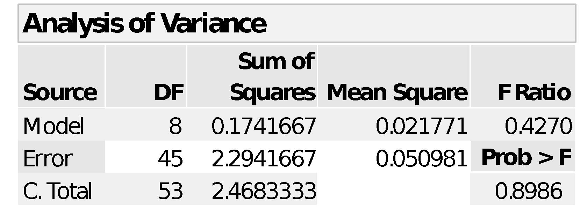
Table 1 Total ANOVA
$${Var}_{Between total}=\frac{{SS}_{Model}}{{SS}_{Total}}* {Var}_{Total}\frac{N-1}{N}= \frac{0.1741667}{2.4683334}*0.04571=0.003225$$
$${Var}_{Within total}=\frac{{SS}_{Error}}{{SS}_{Total}}* {Var}_{Total}\frac{N-1}{N}= \frac{2.294167}{2.4683334}*0.04571=0.042485$$
Sequential sum of squares on the factors are used to calculate the between components as a fraction of the total between variance.
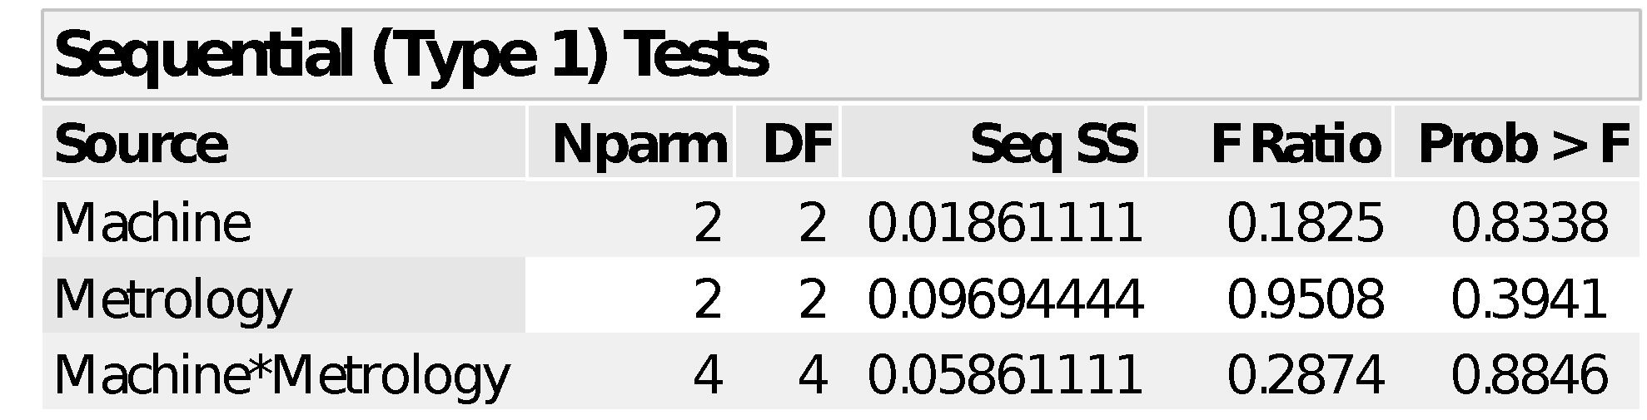
Table 2 Between ANOVA
$${Var}_{Between Machine}=\frac{{SS}_{Machine}}{{SS}_{Total}}* {Var}_{Between Total}= \frac{0.01861111}{0.17416666}*0.003225=0.000345$$
$${Var}_{Between Metrology}=\frac{{SS}_{Metrology}}{{SS}_{Total}}* {Var}_{Between Total}= \frac{0.09694444}{0.174167}*0.003225=0.001795$$
$${Var}_{Between Machine*Metrology}=\frac{{SS}_{Machine*Metrology}}{{SS}_{Total}}* {Var}_{Between Total}= \frac{0.05861111}{0.174167}*0.003225=0.001085$$
For the within variance components, the population variance for each unique combination of factor levels is calculated:
Table 3 Variance table
The common (minimum) variance is equal to 0 as defined by the combination of Machine A, and Metrology Y.
The sequential sums of squares from simple linear regression on this table are used to calculate the within variance components as a fraction of the total within variance. The sample size for each unique factor combination is used as a frequency to allow unbalanced data sets.
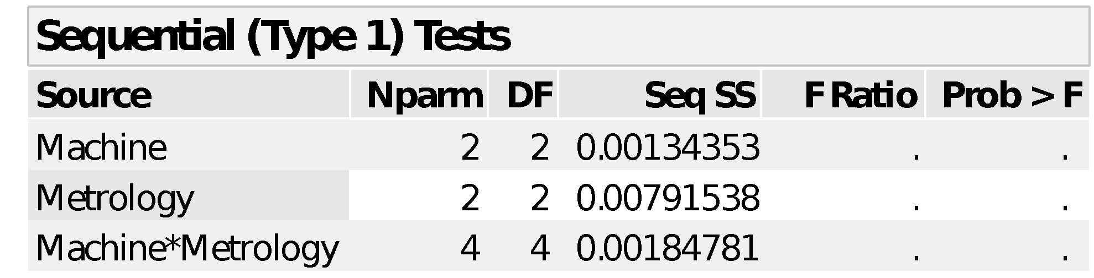
Table 4 Within ANOVA
The common variance is subtracted from the total within variance and the remainder is distributed over the within variance components according to the sequential sum of squares components.
$${Var}_{Within Machine}=\frac{{SS}_{Machine}}{{SS}_{Total}}* {(Var}_{Within Total}-{Var}_{Common})= \frac{0.00134353}{0.01110672}*0.042485=0.005139$$
$${Var}_{Within Metrology}=\frac{{SS}_{Metrology}}{{SS}_{Total}}*{(Var}_{Within Total}-{Var}_{Common})= \frac{0.00791538}{0.01110672}*0.042485=0.030277$$
$${Var}_{Within Machine*Metrology}=\frac{{SS}_{Machine*Metrology}}{{SS}_{Total}}* {(Var}_{Within Total}-{Var}_{Common})= \frac{0.00184781}{0.01110672}*0.042485=0.007068$$
The complete set of variance components is:
 | Variance | % of total | StdDev
Between Total | 0.003225 | 7.06% | 0.056792
Between Machine | 0.000345 | 0.75% | 0.018565
Between Metrology | 0.001795 | 3.93% | 0.042371
Between Machine*Metrology | 0.001085 | 2.37% | 0.032945
Within Total | 0.042485 | 92.94% | 0.206118
Within Machine | 0.005139 | 11.24% | 0.071688
Within Metrology | 0.030277 | 66.24% | 0.174004
Within Machine*Metrology | 0.007068 | 15.46% | 0.084072
Common | 0 | 0% | 0
Total | 0.04571 | 100% | 0.213799
Table 5 Variance components
By using the simple linear regression analysis in JMP, POV can calculate any data structure that can be modelled using multiple linear regression.

Comparison of POV and REML
Since REML is the current standard recommended by United States Pharmacopeia (USP 1033), POV is compared against REML on three simulated bioassay validation samples. The data consists of three factors (analyst, day, instrument) where concentration-response models are built.

Between components
The following is a comparison of the between variance components as calculated with REML and POV.
Figure 4 Visualizing the between components at different factor combinations
REML components are more extreme than POV components. There is a trend away from the middle at a standard deviation of 1.5, where REML variance components are bigger than corresponding POV components above this line smaller below the line. The most extreme example is the Component=Day, Sample=2, Concentration=150 where REML produces a zero between component which does not match the simulation parameters or the visuals.

Within components
Since REML does not calculate within components these cannot be compared. REML only produces a summed error term (repeatability) which can be compared to the sum within components. This term is called intermediate precision in the validation of bioassay’s as recommended by USP <1033> and ICH Q2. When comparing intermediate precision using REML and POV to the population standard deviation the difference between REML and POV becomes even clearer.
Figure 6 Visualization of intermediate precision

 | Concentration | POV | REML | Population StdDev | POV - StdDev inflation | REML - StdDev inflation
Sample 1 | 50 | 4.556 | 6.194 | 4.556 | 0.00% | 34.30%
Sample 1 | 100 | 4.805 | 5.744 | 4.805 | 0.00% | 18.10%
Sample 1 | 150 | 6.443 | 7.839 | 6.443 | 0.00% | 20.40%
Sample 2 | 50 | 4.335 | 5.197 | 4.335 | 0.00% | 18.50%
Sample 2 | 100 | 4.798 | 5.779 | 4.798 | 0.00% | 19.00%
Sample 2 | 150 | 5.631 | 6.248 | 5.631 | 0.00% | 9.80%
Sample 3 | 50 | 5.144 | 6.369 | 5.144 | 0.00% | 22.30%
Sample 3 | 100 | 4.624 | 5.242 | 4.624 | 0.00% | 12.00%
Sample 3 | 150 | 6.166 | 7.321 | 6.166 | 0.00% | 17.50%
Table 6 Inflation of intermediate precision by method
REML inflates the total within variance, POV is exact and predicts all the observed variation. Bigger variance components result in a bigger intermediate precision quantitation. For the same observed data and specification limits, a REML based analysis will fail qualification more often than a POV based analysis. This can be remedied by opening the tolerance window wider, but this will decrease the sensitivity of the bioassay validation making POV a better method to quantitate variance components for the use of bioassay qualification.

Problems with REML
To better visualize the REML zero component problem, another data set is presented:
Figure 5 cement REML variance components
Table 7 POV variance components Cement
Notice that the between Brand*Additive interaction component using REML is zero, but looking at the interaction graph, it is clear that those lines are not parallel and thus the interaction term cannot be zero. The zero is a misleading result. POV calculates a realistic number.

Recommendations and conclusions
POV variance components analysis gives numbers that are closer to the true group standard deviation and as such are a better description of the variance components. The between and within components are necessarily closer to the true values as well, in fact the usage of the sequential sums of squares in the calculation of POV guarantees an exact description of the variance components.
POV gives us more insight into the data by parsing out the within variation into its constituent components. REML does not break down the repeatability into its constituent components limiting the information extracted from the data.
Using POV there is less variance inflation making it a more reliable method in all three of the tested conditions. REML based analysis will regularly fail process qualification specification limits that are passed when POV is used.
Because of the exactness and completeness of the calculation, POV needs to become the standard for variance components estimation in most applications

References
NIST variance components https://www.itl.nist.gov/div898/handbook/prc/section4/prc44.htm
United States Pharmacopeia www.usp.org particularly USP <1033>
ICH particularly Q2 Analytical validation https://www.ich.org/page/quality-guidelines
Bartlett, M. S. (1937). "Properties of Sufficiency and Statistical Tests". Proceedings of the Royal Society A: Mathematical, Physical and Engineering Sciences. 160 (901): 268. Bibcode:1937RSPSA.160..268B. doi:10.1098/rspa.1937.0109.

Patterson, H. D.; Thompson, R. (1971). "Recovery of inter-block information when block sizes are unequal". Biometrika. 58 (3): 545. doi:10.1093/biomet/58.3.545.

Data examples: https://github.com/PaulAntonDeen/Papers/tree/master/1%20POV%20an%20explanation%20and%20comparison%20of%20variance%20components%20analysis%20methods/Data

